**WEEK 5 – 12/08**

Program 1:

Output:

Program 2:

abstract class Main {

public String fname = "john";

public int age = 24;

public abstract void study();

}

class Student extends Main{

public int grad_yeat = 2018;

public void study(){

System.out.println("Studying all day long");

}

}

//second file

class Second {

public static void main(String[] args){

Student my_obj = new Student();

System.out.println("Name: " + my_obj.fname);

System.out.println("Age: " + my_obj.age);

System.out.println("Graduation year: " + my_obj.grad_year);

my_obj.study();

}

}

Output:

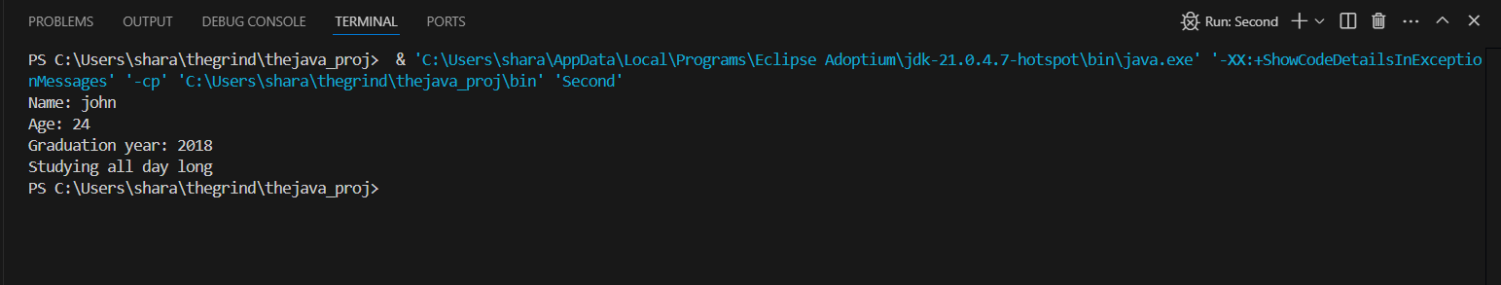

Program 3: